# Overview of MongoDB and the Document Model

# BSON Types

[BSON](https://www.mongodb.com/docs/manual/reference/glossary/#std-term-BSON) is a binary serialization format used to store documents and make remote procedure calls in MongoDB. The BSON specification is located at [bsonspec.org](http://bsonspec.org/).

Each BSON type has both integer and string identifiers as listed in the following table:

| **Type** | **Number** | **Alias** | **Notes** |
| --- | --- | --- | --- |
| Double | 1 | "double" |  |
| String | 2 | "string" |  |
| Object | 3 | "object" |  |
| Array | 4 | "array" |  |
| Binary data | 5 | "binData" |  |
| Undefined | 6 | "undefined" | Deprecated. |
| ObjectId | 7 | "objectId" |  |
| Boolean | 8 | "bool" |  |
| Date | 9 | "date" |  |
| Null | 10 | "null" |  |
| Regular Expression | 11 | "regex" |  |
| DBPointer | 12 | "dbPointer" | Deprecated. |
| JavaScript | 13 | "javascript" |  |
| Symbol | 14 | "symbol" | Deprecated. |
| 32-bit integer | 16 | "int" |  |
| Timestamp | 17 | "timestamp" |  |
| 64-bit integer | 18 | "long" |  |
| Decimal128 | 19 | "decimal" |  |
| Min key | -1 | "minKey" |  |
| Max key | 127 | "maxKey" |  |



In this unit, you learned about the relationship between MongoDB and Atlas. MongoDB is a general-purpose database that can be used for a variety of use cases. It’s part of Atlas, the developer data platform. You also learned about the MongoDB document model. Specifically, you learned about these key features:

* Data is organized into documents, collections, and databases.
* Documents are stored in BSON, which supports a large range of data types, including all JSON data types, dates, numbers, and ObjectIds.
* Every document requires an _id field, which acts as a primary key or unique identifier. If an inserted document doesn’t have an _id field, MongoDB automatically generates one.
* MongoDB has a flexible schema, which means that documents with different structures can be stored in the same collection.

Finally, you learned how to use Atlas Data Explorer to create a database, collection, and a document and begin storing your own data.

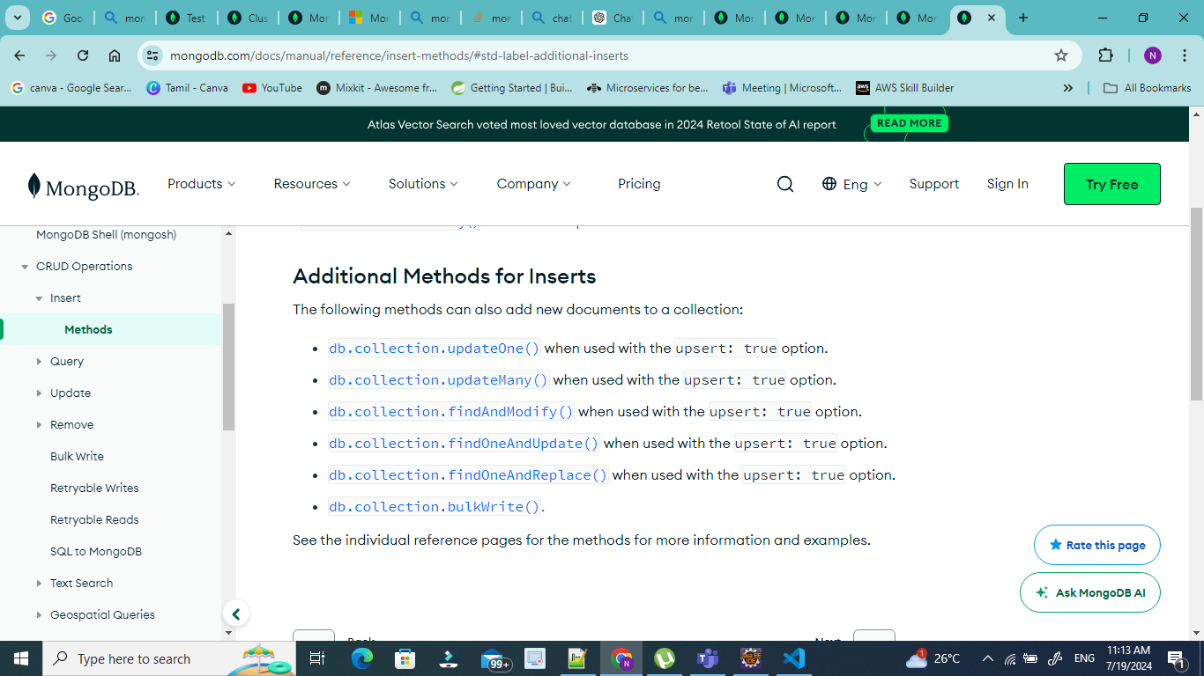

The following methods can also add new documents to a collection:

* [db.collection.updateOne()](https://www.mongodb.com/docs/manual/reference/method/db.collection.updateOne/#mongodb-method-db.collection.updateOne) when used with the upsert: true option.
* [db.collection.updateMany()](https://www.mongodb.com/docs/manual/reference/method/db.collection.updateMany/#mongodb-method-db.collection.updateMany) when used with the upsert: true option.
* [db.collection.findAndModify()](https://www.mongodb.com/docs/manual/reference/method/db.collection.findAndModify/#mongodb-method-db.collection.findAndModify) when used with the upsert: true option.
* [db.collection.findOneAndUpdate()](https://www.mongodb.com/docs/manual/reference/method/db.collection.findOneAndUpdate/#mongodb-method-db.collection.findOneAndUpdate) when used with the upsert: true option.
* [db.collection.findOneAndReplace()](https://www.mongodb.com/docs/manual/reference/method/db.collection.findOneAndReplace/#mongodb-method-db.collection.findOneAndReplace) when used with the upsert: true option.
* [db.collection.bulkWrite().](https://www.mongodb.com/docs/manual/reference/method/db.collection.bulkWrite/#mongodb-method-db.collection.bulkWrite)

With the update operations, the aggregation pipeline can consist of the following stages:

* [$addFields](https://www.mongodb.com/docs/manual/reference/operator/aggregation/addFields/#mongodb-pipeline-pipe.-addFields)
* [$set](https://www.mongodb.com/docs/manual/reference/operator/aggregation/set/#mongodb-pipeline-pipe.-set)
* [$project](https://www.mongodb.com/docs/manual/reference/operator/aggregation/project/#mongodb-pipeline-pipe.-project)
* [$unset](https://www.mongodb.com/docs/manual/reference/operator/aggregation/unset/#mongodb-pipeline-pipe.-unset)
* [$replaceRoot](https://www.mongodb.com/docs/manual/reference/operator/aggregation/replaceRoot/#mongodb-pipeline-pipe.-replaceRoot)
* [$replaceWith](https://www.mongodb.com/docs/manual/reference/operator/aggregation/replaceWith/#mongodb-pipeline-pipe.-replaceWith)

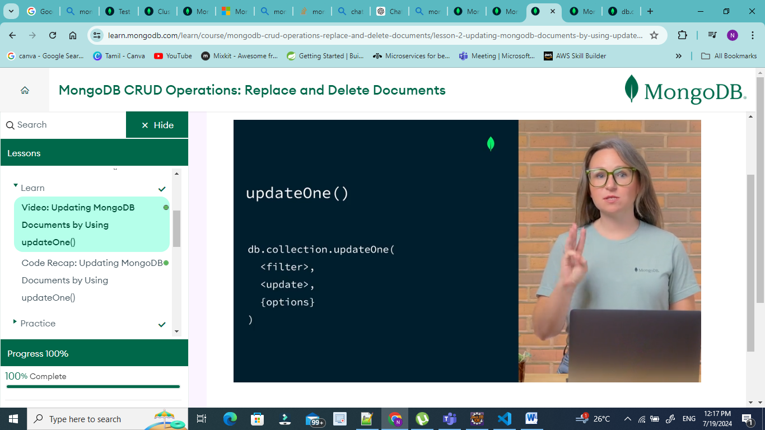

Filter doc for selection criteria, update document for selection criteria, options objects – optional one.

Query on Nested Field with Dot Notation

To specify a query condition on fields in an embedded/nested document, use [dot notation](https://www.mongodb.com/docs/manual/reference/glossary/#std-term-dot-notation) ("field.nestedField").

|  |
| --- |
| const cursor = db.collection(**'inventory'**).find({ |
| size: { h: 14, w: 21, uom: **'cm'** } |
| }); |

Unpredictable results:

|  |
| --- |
| size: { w: 21, h: 14, uom: **'cm'** } |
|  |

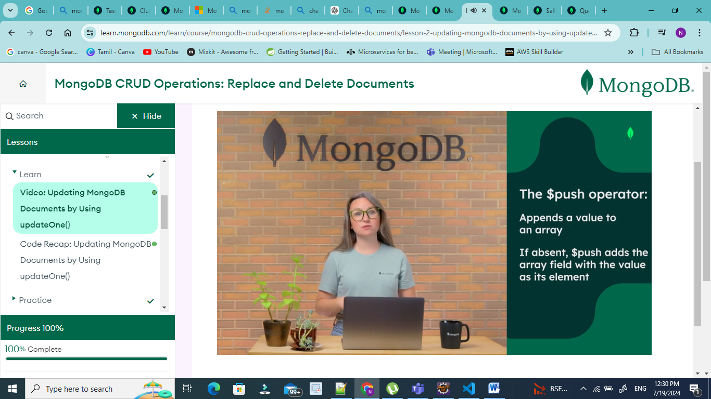

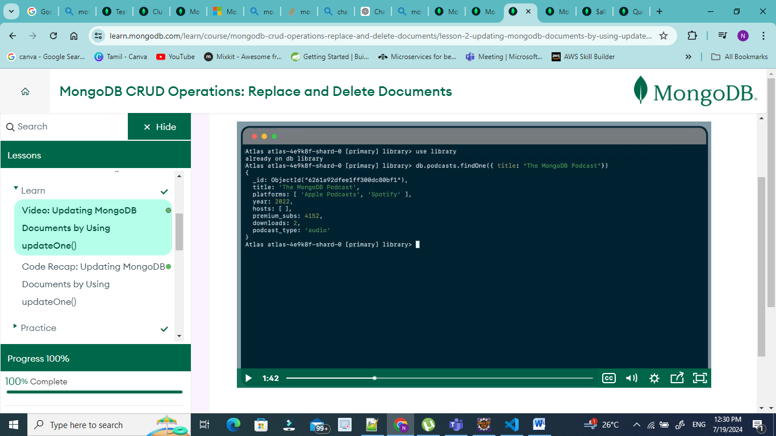

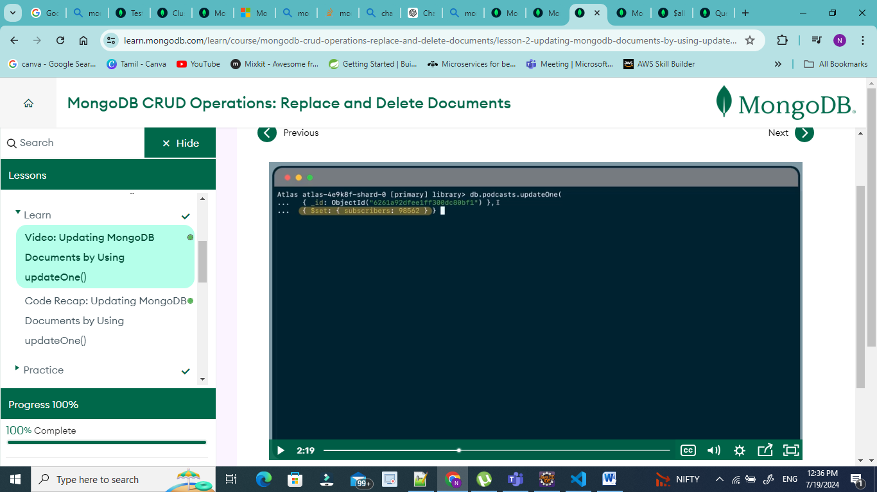

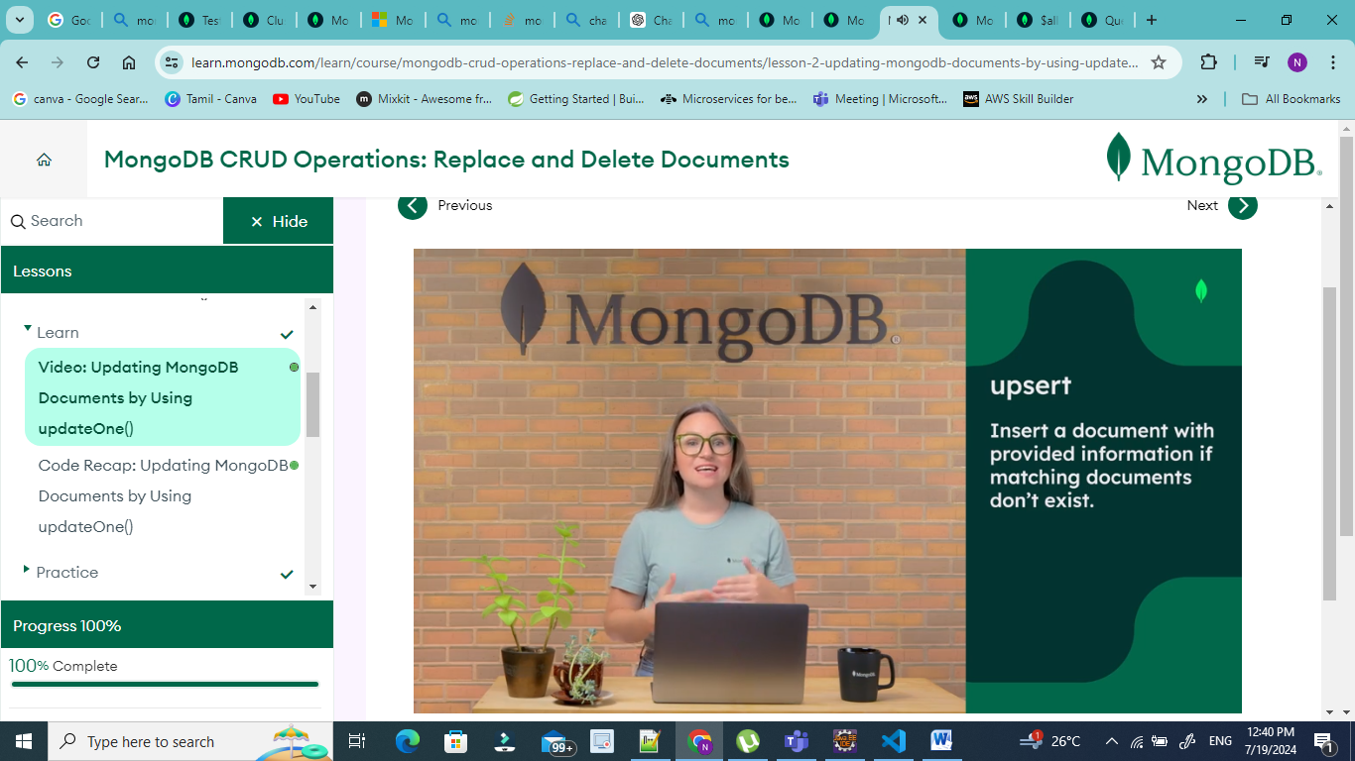

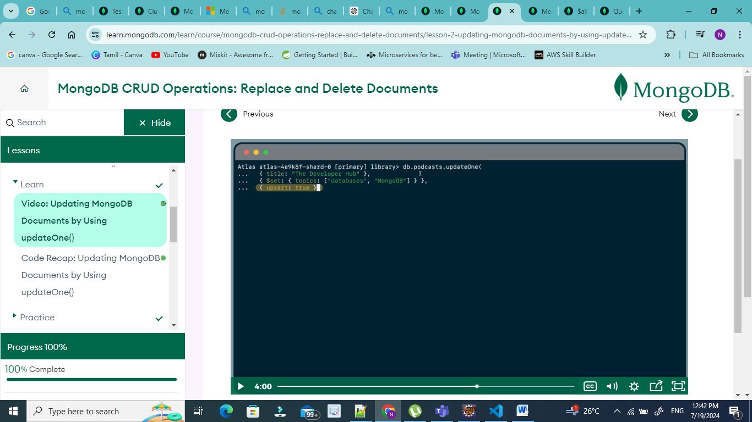

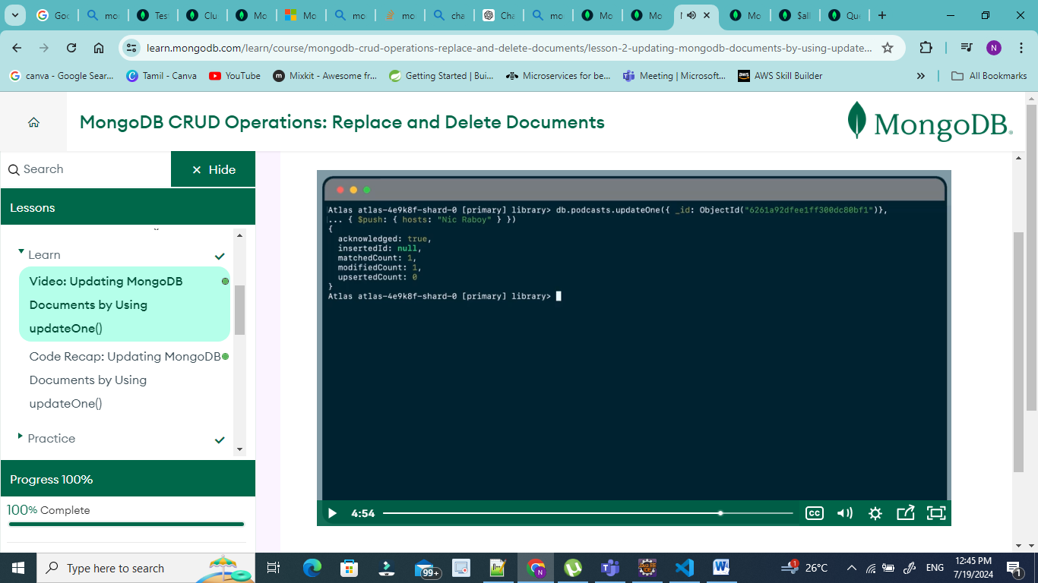

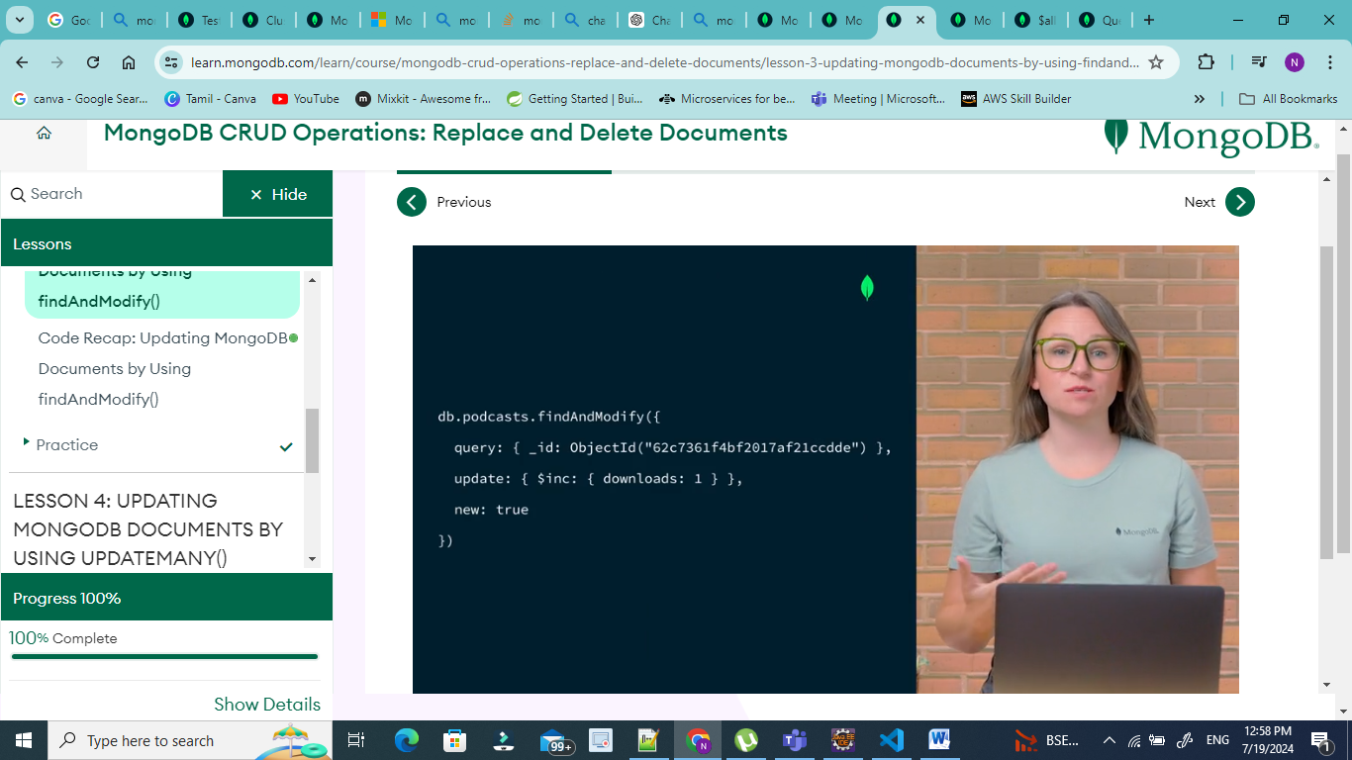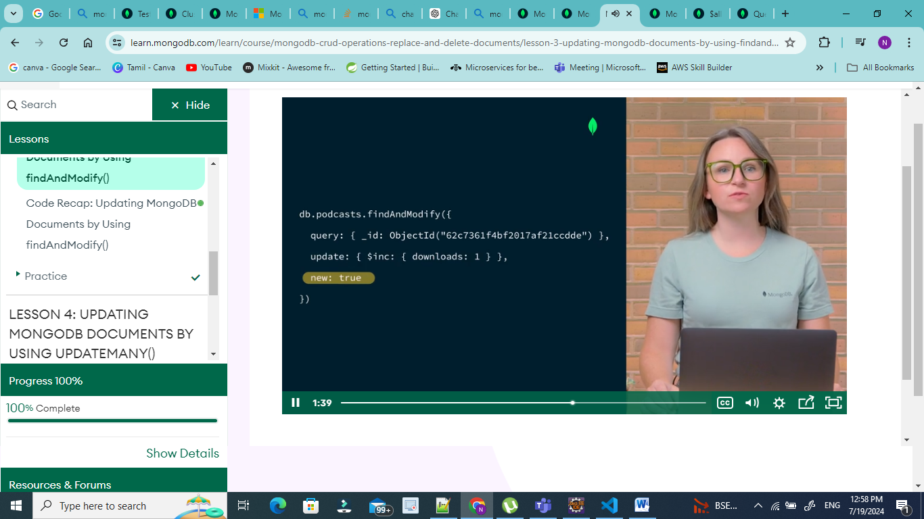

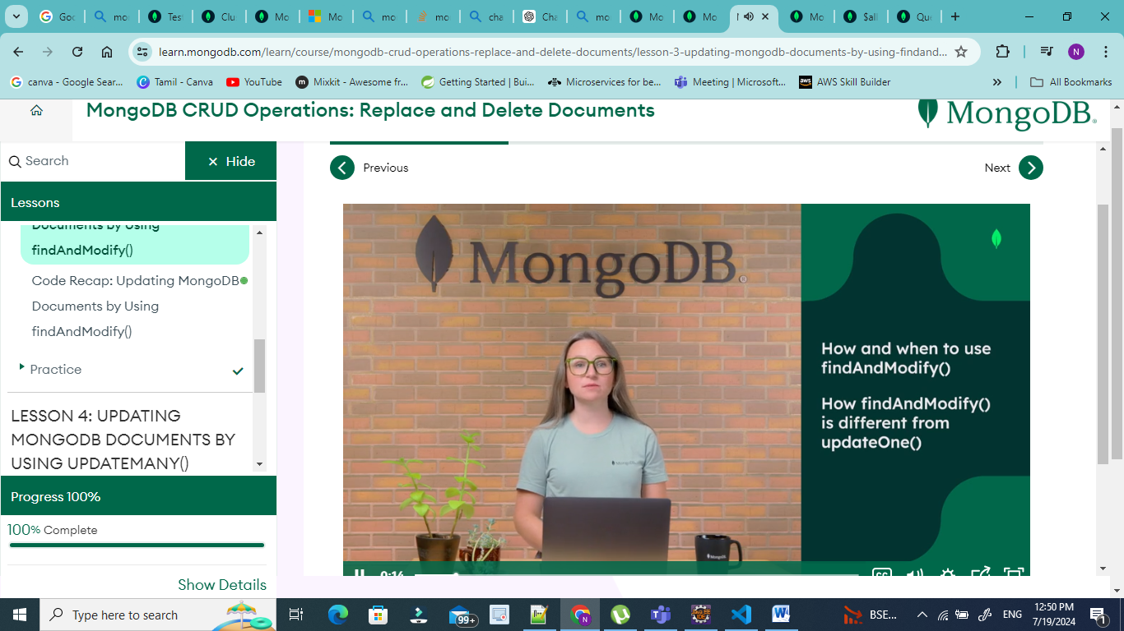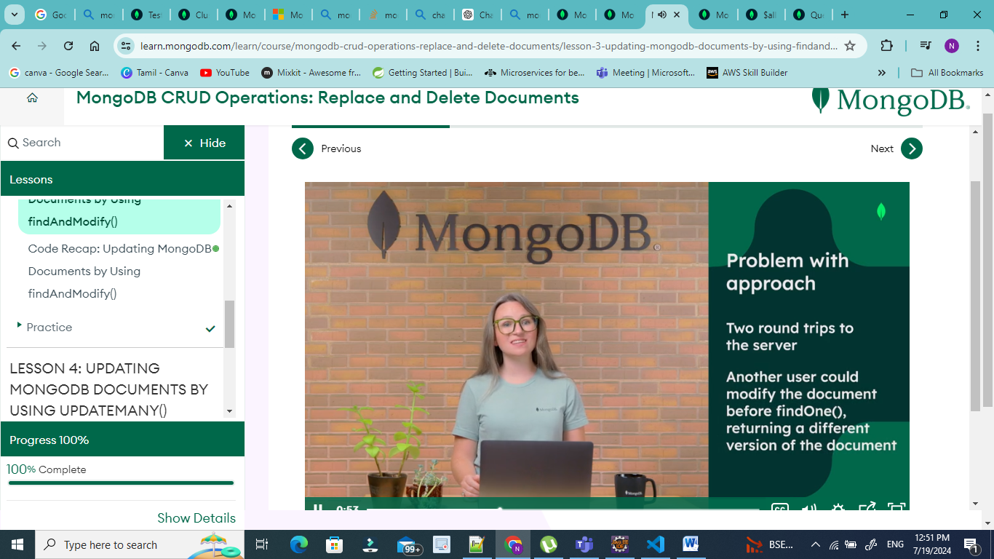

The findAndModify() method is used to find and replace a single document in MongoDB. It accepts a filter document, a replacement document, and an optional options object. The following code shows an example:

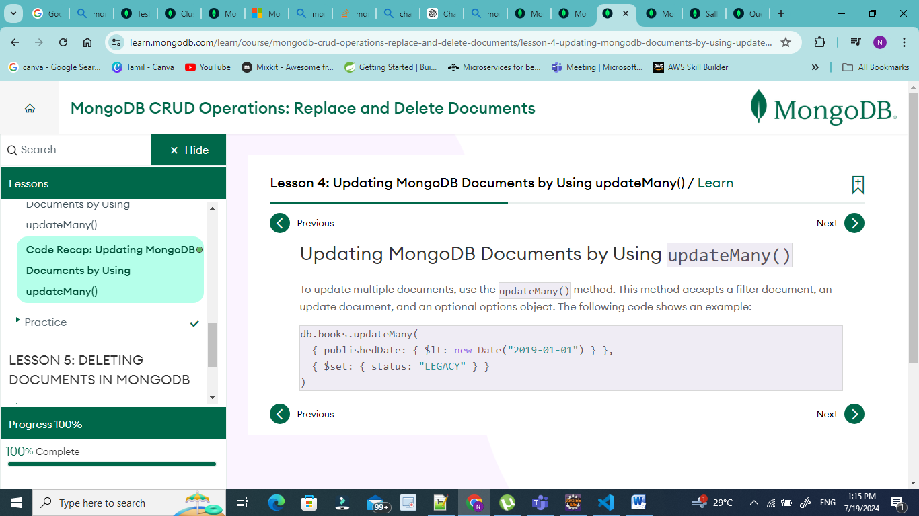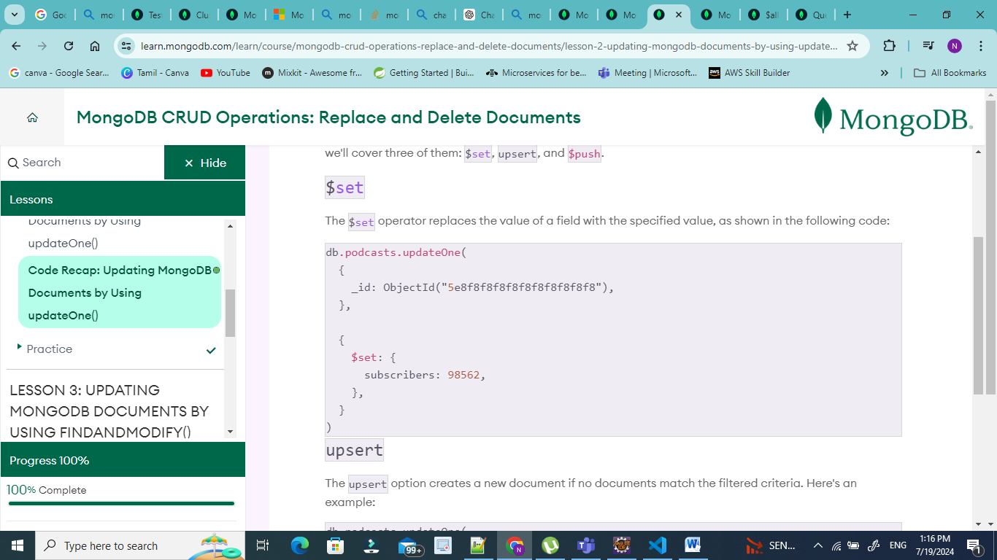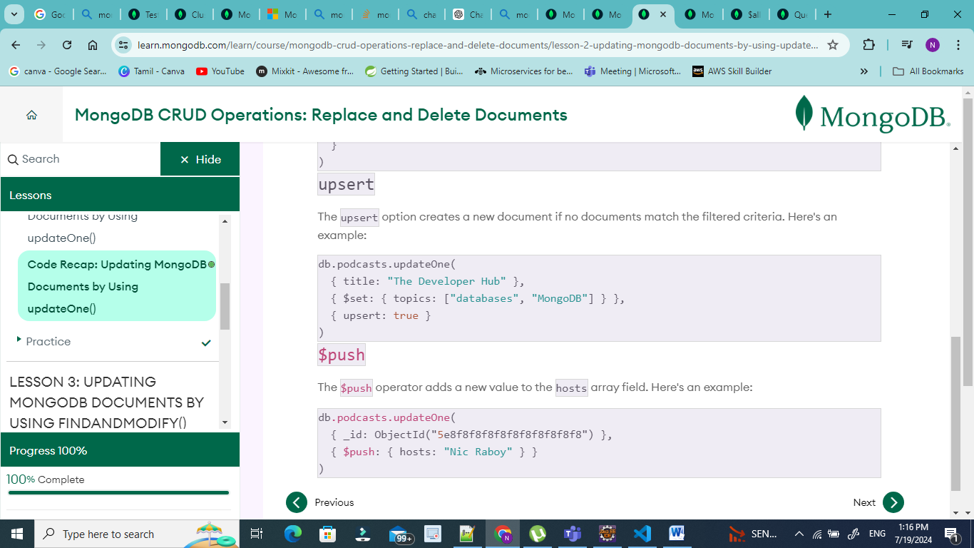

# The MongoDB Document Model

Review the following code, which demonstrates the structure of a document.

## Document Structure

The values in a document can be any data type, including strings, objects, arrays, booleans, nulls, dates, ObjectIds, and more. Here's the syntax for a MongoDB document, followed by an example:

Syntax:

{

"key": value,

"key": value,

"key" : value

}

Example:

{

"_id": 1,

"name": "AC3 Phone",

"colors" : ["black", "silver"],

"price" : 200,

"available" : true

}

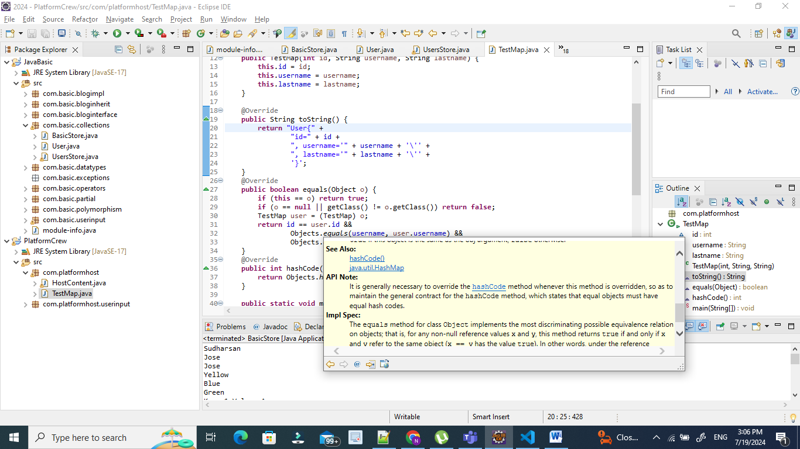

* 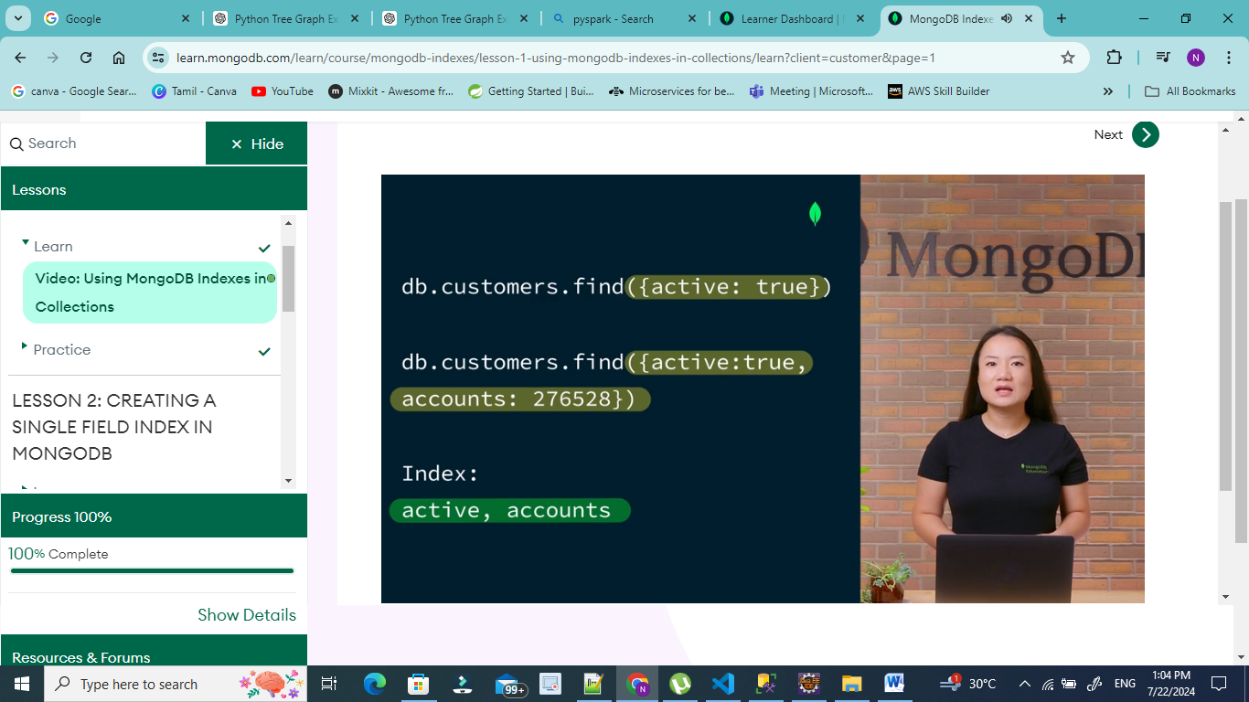**Compound index:** MongoDB supports compound indexes, where a single index structure holds references to multiple fields within a collection's documents. A compound index is created by specifying the fields that the index should reference, followed by the order in which the fields should be sorted. The order of the fields in the index is important because it determines the order in which the documents are returned when querying the collection. A compound index can also be a multikey index if one of the fields is an array.

[Previous](https://learn.mongodb.com/learn/course/mongodb-indexes/lesson-1-using-mongodb-indexes-in-collections/practice?client=customer&page=1)

**Multikey index:** A multikey index is an index on an array field. Each element in the array gets an index key, which supports efficient querying against array fields. Both single field and compound indexes can have an array field, so there are both multikey single field indexes and multikey compound indexes.

# Understanding Multikey Indexes

Review the code below, which demonstrates how multikey indexes work. If a single field or compound index includes an array field, then the index is a multikey index.

## Create a Single field Multikey Index

Use createIndex() to create a new index in a collection. Include an object as parameter that contains the array field and sort order. In this example accounts is an array field.

db.customers.createIndex({

accounts: 1

})

## View the Indexes used in a Collection

Use getIndexes() to see all the indexes created in a collection.

db.customers.getIndexes()

## Check if an index is being used on a query

Use explain() in a collection when running a query to see the Execution plan. This plan provides the details of the execution stages (IXSCAN , COLLSCAN, FETCH, SORT, etc.).

* The IXSCAN stage indicates the query is using an index and what index is being selected.
* The COLLSCAN stage indicates a collection scan is perform, not using any indexes.
* The FETCH stage indicates documents are being read from the collection.
* The SORT stage indicates documents are being sorted in memory.

db.customers.explain().find({

accounts: 627788

})

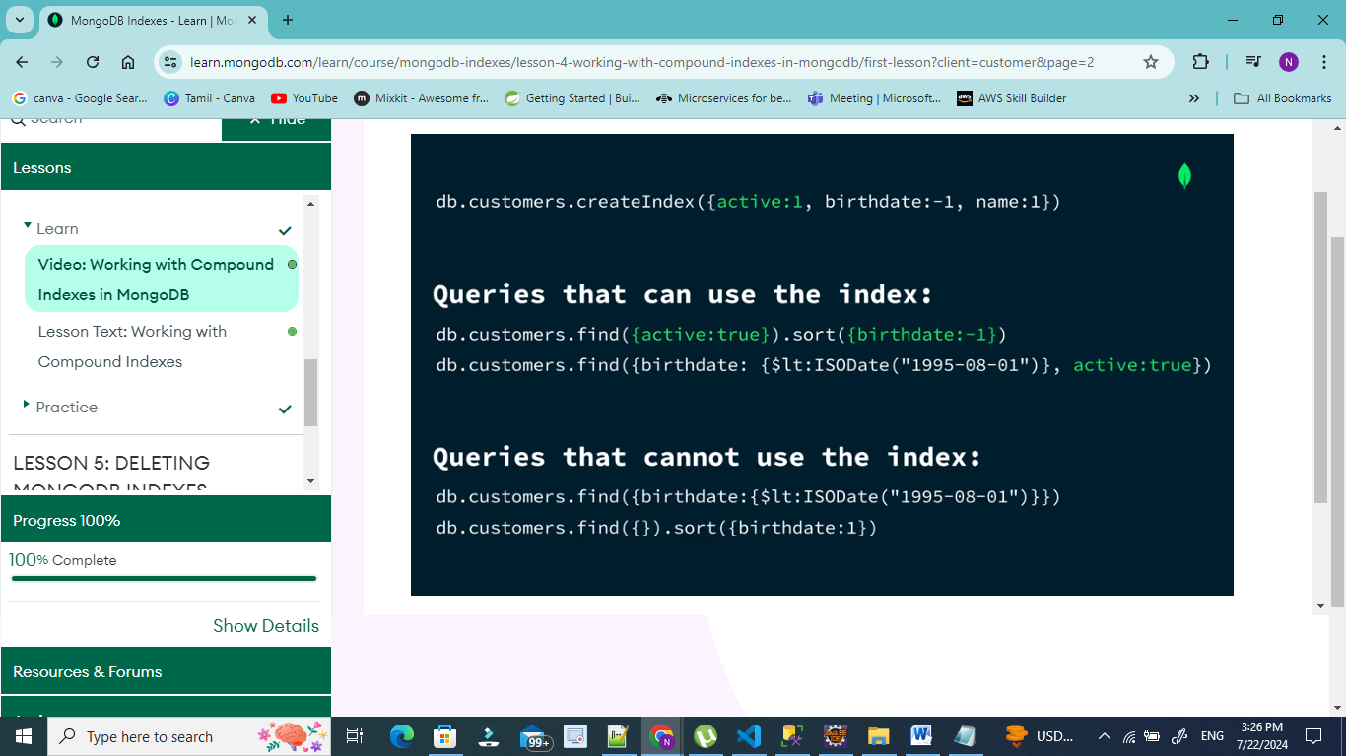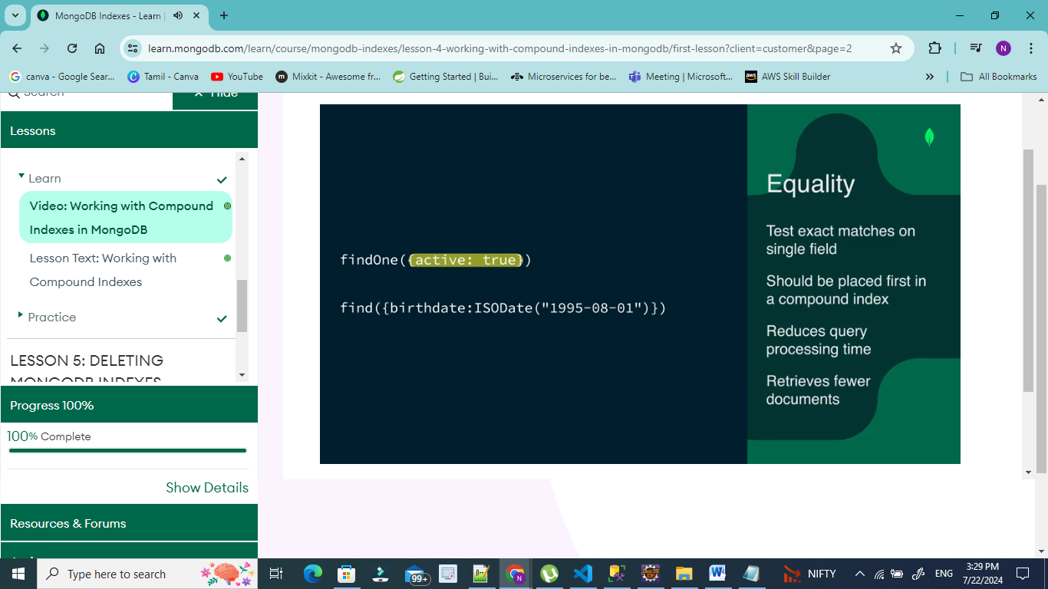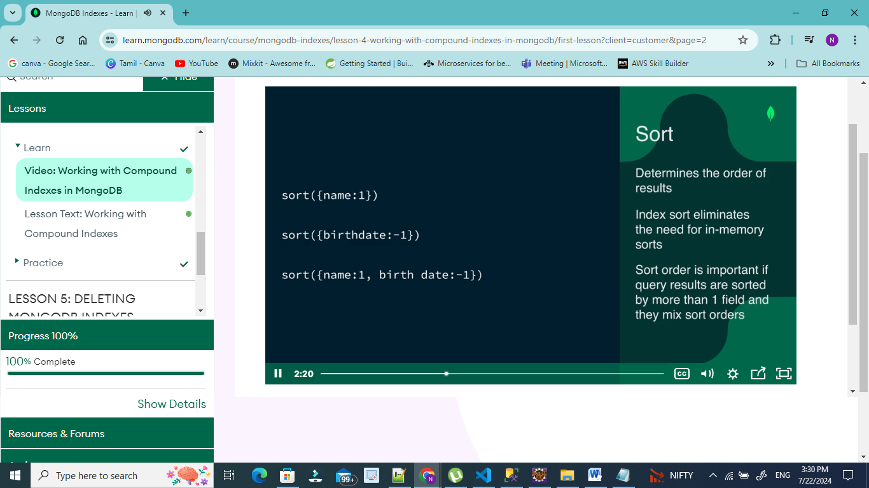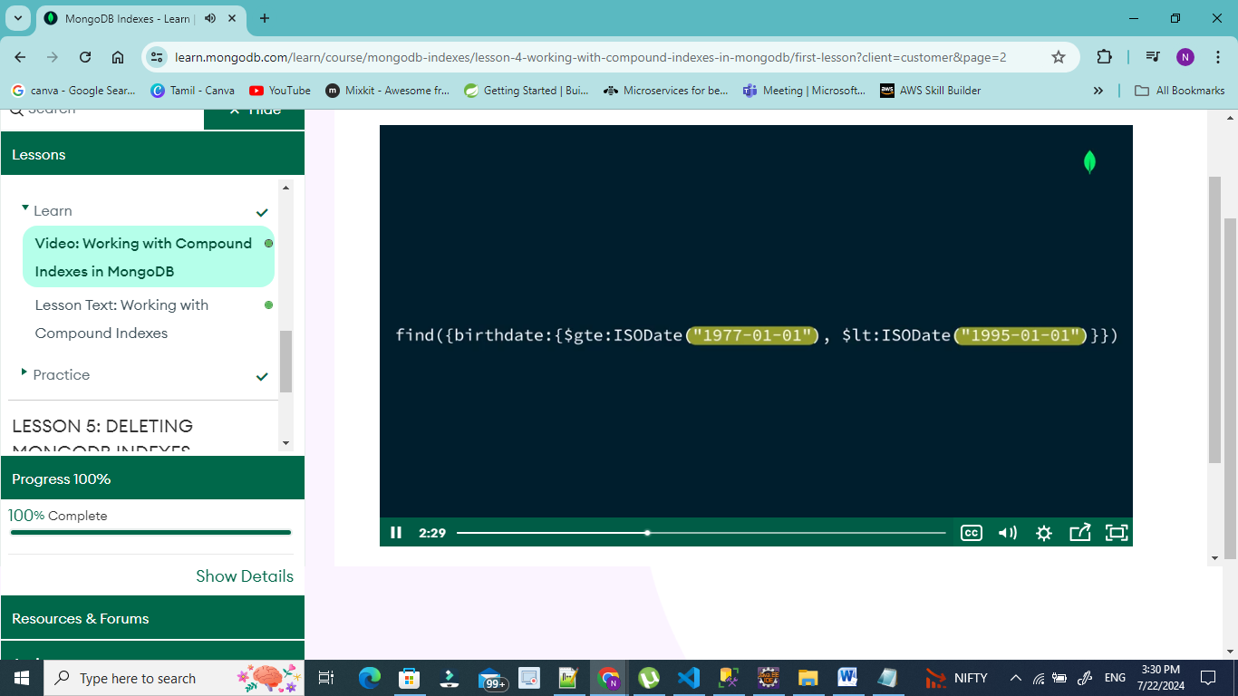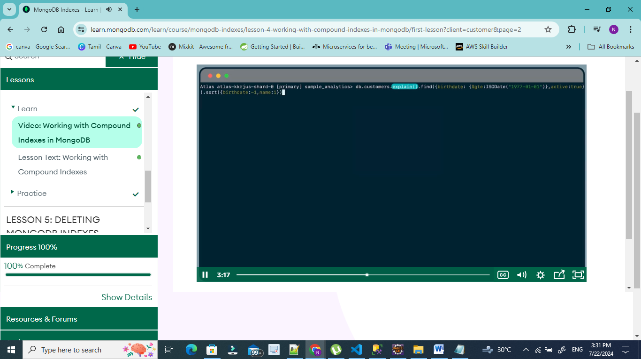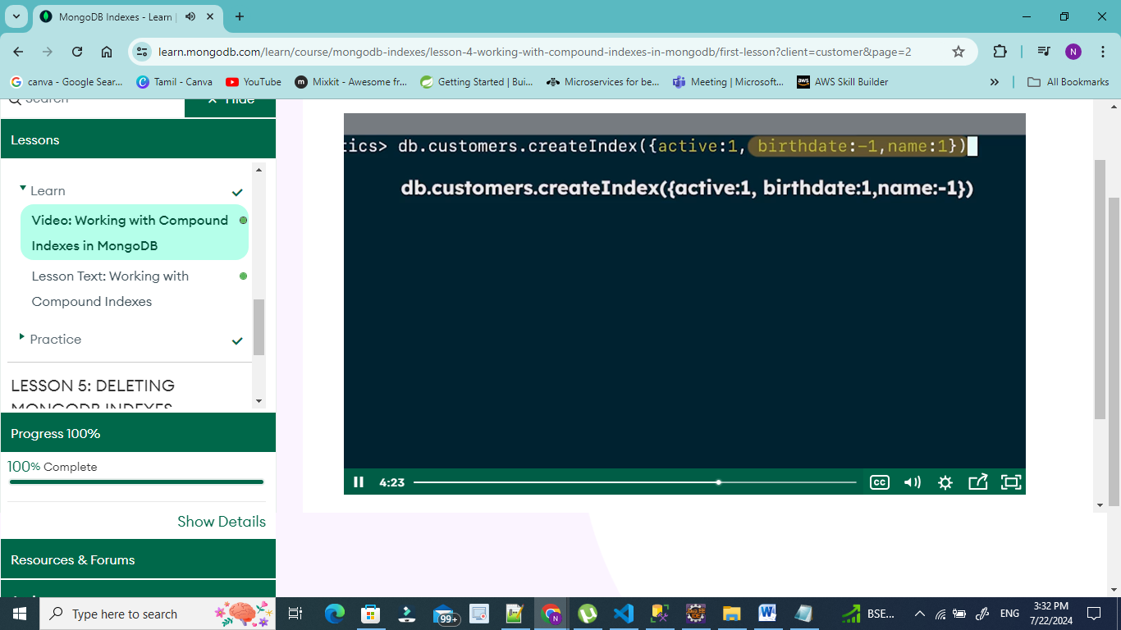

Projections, 1 & 0

Sort:

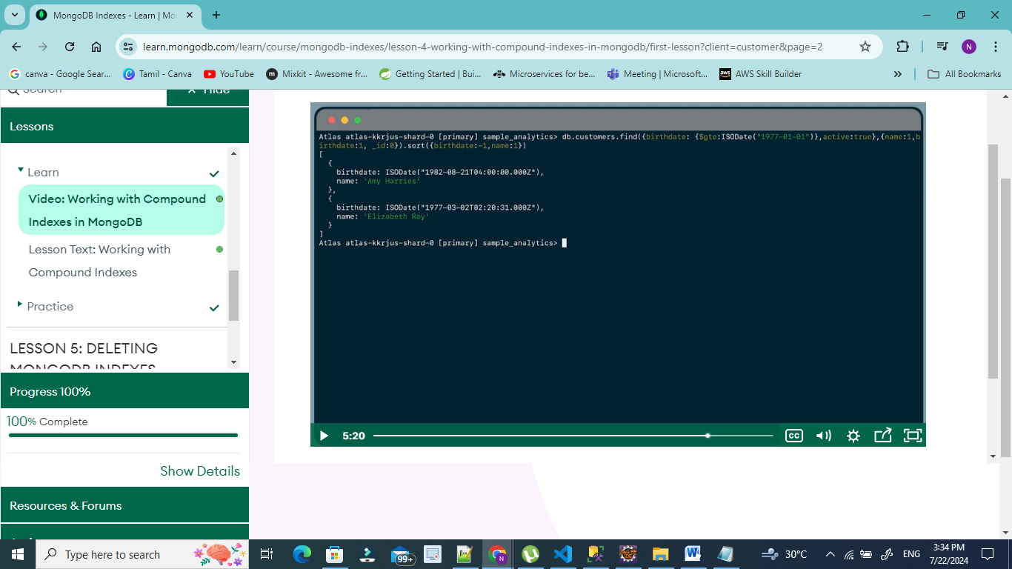

Projection: 1 and 0

Sort: 1 and -1

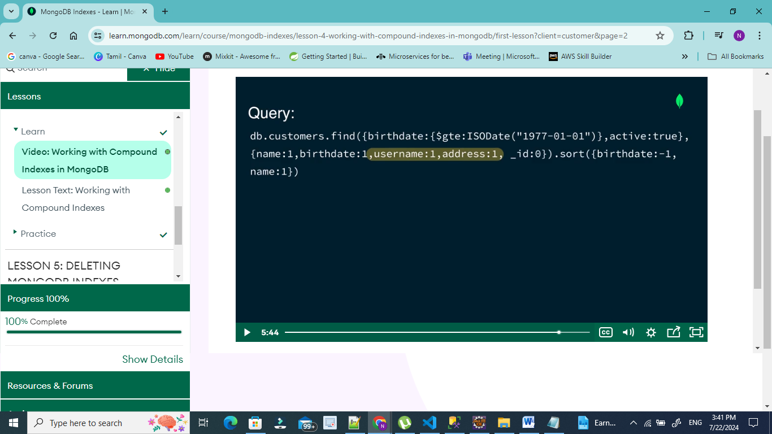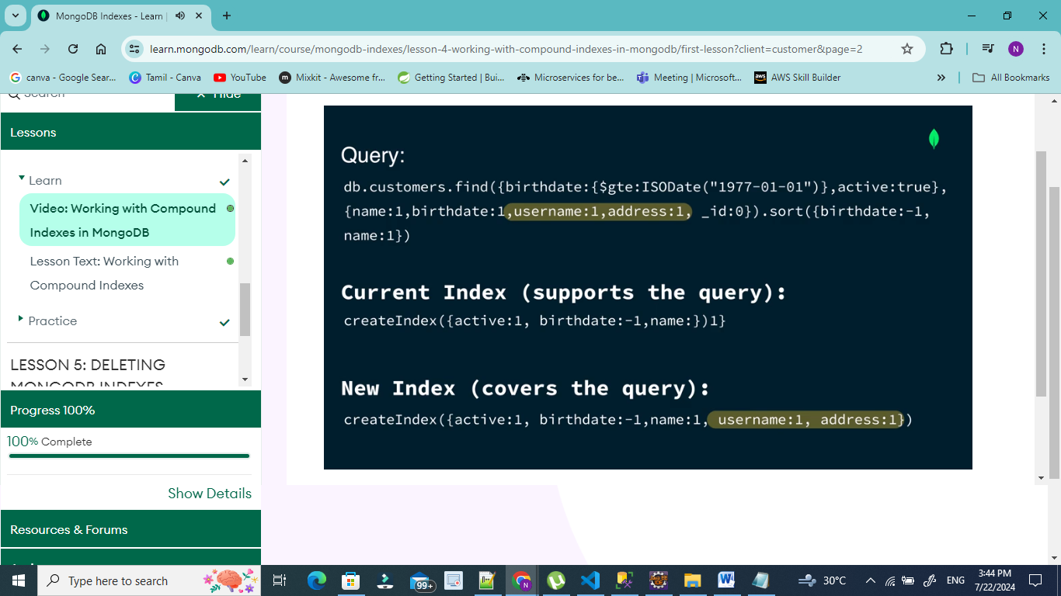

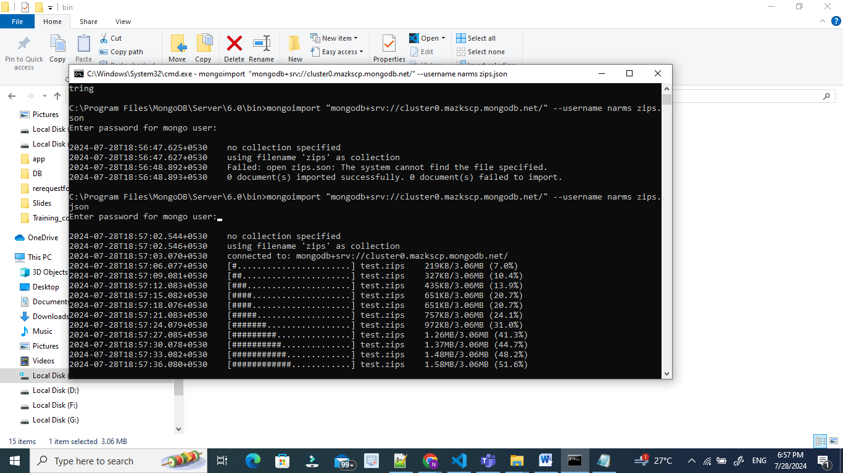

C:\Program Files\MongoDB\Server\6.0\bin>mongoimport "mongodb+srv://cluster0.mazkscp.mongodb.net/" --username narms zips.json

Enter password for mongo user:

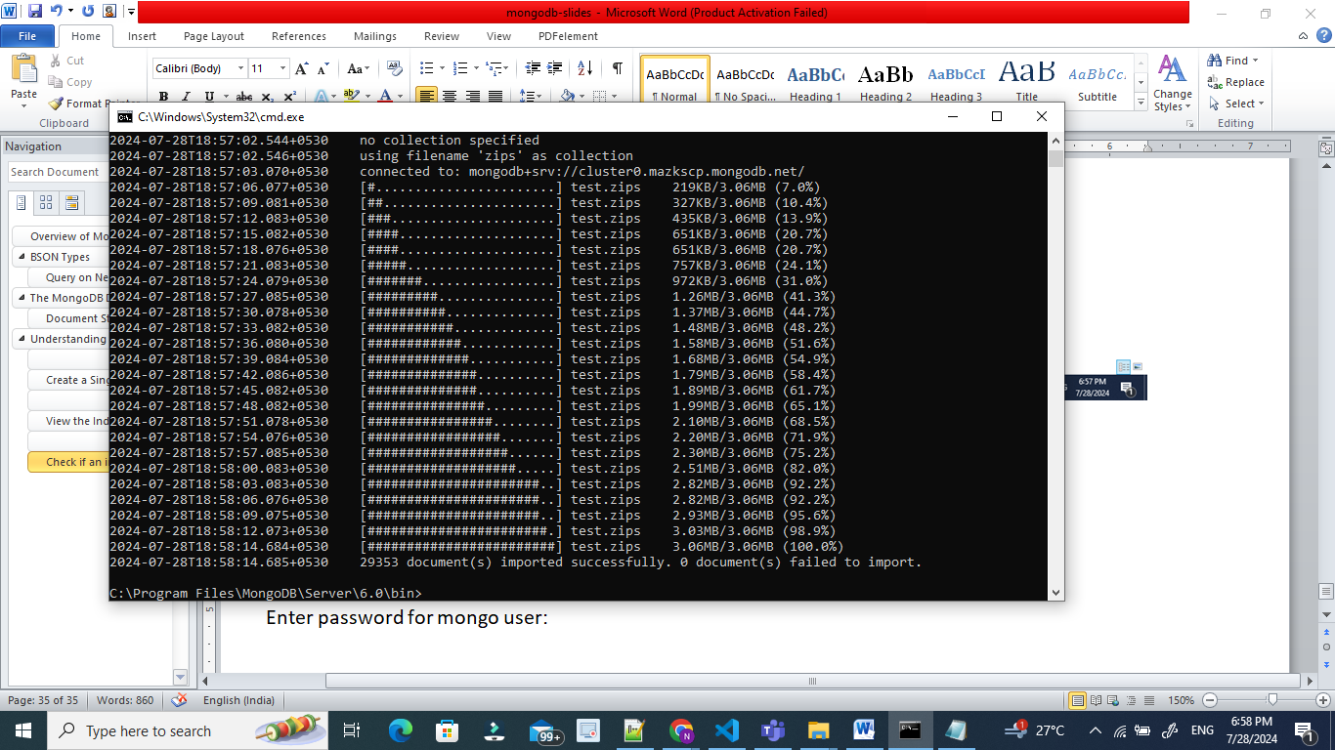

>mongoimport --db=vikram1 --collection=zipcodes --file=zips.json